SESSION 10: SOLUTION DESIGN & VALIDATION

THE REAL-WORLD EXAMPLE

A bank spent $2M building a 'perfect' CRM system. Requirements were met. Code was flawless. Launch day: Sales team revolted. Why? The 'Contact Customer' button was buried 4 clicks deep. Their old spreadsheet: 1 click.

Lesson: Perfect requirements ≠ Usable solution.

The BA's New Role: "You're no longer just a requirements writer. You're a user experience designer and solution validator

USE CASES & SCENARIOS

Use Case vs User Story (Simple Difference):

USER STORY (Agile):
As a sales rep, I want to see my pipeline so I can forecast revenue.

USE CASE (Detailed):
Primary Actor: Sales Rep
Goal: View sales pipeline
Pre-condition: Logged into CRM

Steps:
1. Click 'Dashboard' tab
2. Select 'Pipeline View'
3. Filter by quarter
4. Export to Excel

Post-condition: Pipeline data exported

CRM Use Case Example
Use Case: Update Customer Contact Information
ID: UC-CRM-007
Name: Update Customer Contact
Actor: Sales Representative
Description: Update customer phone/email in CRM

MAIN SUCCESS SCENARIO:
1. Sales rep searches for customer
2. System displays customer record
3. Sales rep clicks 'Edit Contact'
4. System shows editable contact form
5. Sales rep updates phone number
6. Sales rep saves changes
7. System confirms update, logs change

ALTERNATE SCENARIOS:
3a. Customer not found → Show 'Create New' option
6a. Invalid phone format → Show error message
6b. Duplicate phone number → Show warning

Scenario Writing Exercise
Scenario: "Sales rep needs to qualify a lead quickly before a meeting"
Student Task: Write 3 steps of the MAIN scenario and 1 ALTERNATE scenario.

Example Answer:

WIREFRAMING & PROTOTYPING

Why Wireframe? The "Building a House" Analogy:

Blueprint (Wireframe) → Show client → Get approval → Build house
No Blueprint → Build → Client says "Windows are wrong!" → Costly rebuild

Wireframe Fidelity Levels:

1. Low-Fidelity (Sketches) - PAPER
- Quick, disposable
- Focus on layout, not colors
- When: Brainstorming sessions

2. Mid-Fidelity (Grayscale)
- Clear structure
- Placeholder text/images
- When: Stakeholder reviews

3. High-Fidelity (Pixel-Perfect) - FIGMA
- Final design
- Real content, colors, branding
- When: Developer handoff

Demo: CRM Dashboard Wireframe (Figma)

Step 1: Layout Planning (Whiteboard)
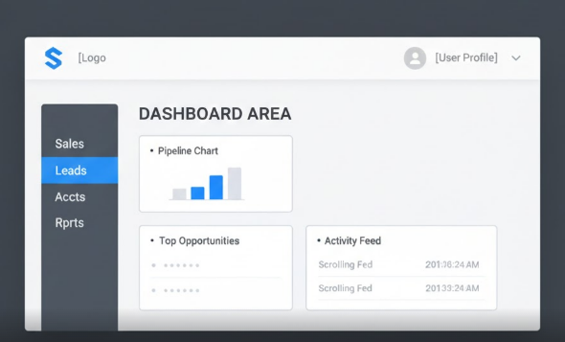

going to this from

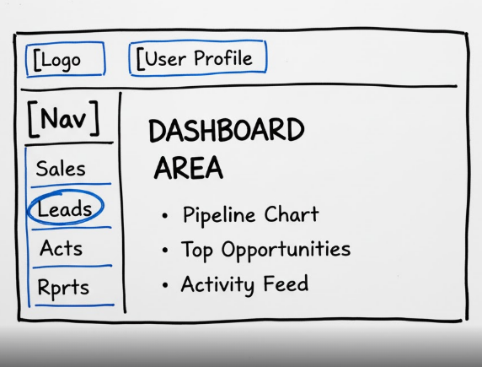

Step 2: Create in Tool

Figma Example (Low-Fi):

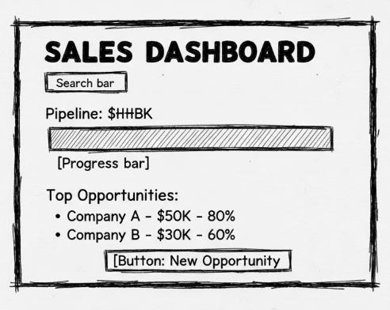

Step 3: Annotate Wireframe
[1] Pipeline total updates in real-time
[2] Click opportunity to view details
[3] Red = at risk, Green = on track
[4] Export to PDF/Excel option

Exercise: Design a Lead Capture Form
Requirements:
- Capture: Name, Email, Company, Phone, Source
- Validate email format
- Show success/error messages

Task: Sketch wireframe on paper, then create in tool.

ACCEPTANCE CRITERIA DEFINITION

The Difference That Matters:
REQUIREMENT: "System shall send email notifications"
ACCEPTANCE CRITERIA:

1. WHEN lead status changes to 'Qualified' trigger condition
2. THEN email sends to assigned sales rep target aud
3. AND email includes lead details prevent empty and useless email
4. AND email sends within 5 minutes time bound
5. AND success logs in activity history helps debbugging , tracking

GIVEN-WHEN-THEN Format (Behavior-Driven Development):
CRM Example: Lead Assignment

GIVEN a new lead enters the system (pre-condition)
WHEN lead score is above 75 business rule
THEN assign to available sales rep sys action
AND send mobile notification
AND log assignment in activity feed

Good vs Bad Acceptance Criteria:
BAD (Vague):
- "Email should work"
- "Page loads quickly"
- "User can save data"

GOOD (Specific & Testable):
- "WHEN user clicks 'Save' THEN show 'Saved successfully' message for 3 seconds"
- "System shall load dashboard in under 2 seconds for 100 concurrent users"
- "User can save draft every 30 seconds automatically"

Exercise: Write AC for CRM Features

Feature 1: "Export Contact List"

GIVEN sales rep views contact list
WHEN they click 'Export'
THEN download CSV file
AND file includes: Name, Email, Company, Last Contact
AND file downloads within 10 seconds

Feature 2: "Merge Duplicate Contacts"

GIVEN two duplicate contacts exist
WHEN user selects 'Merge'
THEN show preview of merged data
AND ask for confirmation
AND preserve activity history from both

SOLUTION ASSESSMENT

The BA's "Solution Doctor" Checklist:

1. Usability Assessment:
- Can user complete task in ≤ 3 clicks?
- Is navigation intuitive?
- Are error messages helpful?

2. Technical Feasibility:
- Does it integrate with existing systems?
- What's the performance impact?
- Any security concerns?

3. Business Value Check:
- Does it solve the REAL problem?
- ROI positive? (Time saved > Cost)
- Aligns with business goals?

CRM Dashboard Assessment Exercise:

Scenario: Proposed CRM dashboard with 15 widgets, real-time data, fancy animations
Assessment Questions:
1. Will it load slowly on sales reps' old laptops? (Performance)
2. Do sales reps NEED all 15 widgets? (Usability)
3. Can we build it in 3 months with our team? (Feasibility)
4. Will it actually increase sales? (Value)

PRACTICAL - DESIGN CRM DASHBOARD

Scenario: Sales Team Dashboard Redesign

Current Problems:
1. 6 different reports to check daily
2. No mobile access
3. Data is 24 hours old
4. Can't drill down into details

Requirements from Sales:
- "See my pipeline at a glance"
- "Know which deals need attention"
- "Access from my phone"
- "Export data for meetings"

Step-by-Step Design Workshop:

Step 1: Identify Users & Needs
```
Users:
1. Sales Rep (daily user)
Needs: Quick view, mobile access
2. Sales Manager (weekly user)
Needs: Team performance, forecasting
3. Executive (monthly user)
Needs: High-level trends, KPIs

Step 2: Sketch Wireframes
- Mobile view (Sales rep)
- Desktop view (Manager)
- Executive summary view

Step 3: Define Acceptance Criteria
- Performance: Loads in < 3 seconds
- Data: Updates every 15 minutes
- Mobile: Works on iOS & Android
- Export: One-click to PDF/Excel

Step 4: Create in Tool
Using Balsamiq/Figma to create final wireframe

Sample CRM Dashboard Wireframe:
Desktop Version:
```
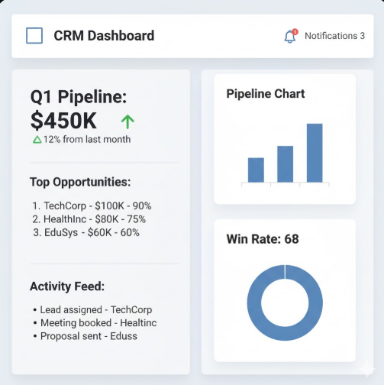
```

Mobile Version:
```
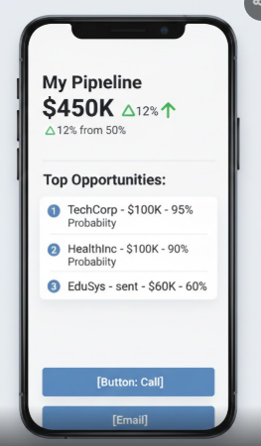

1. Draw.io
- Basic wireframing shapes
- Good for flowchart + wireframe combos

2. Google Slides/PPT
- Shapes + text boxes
- For simple mockups

PRACTICE:
Assignment: Design a "Customer Support Ticket Dashboard"

Hints: Requirements from Support Team:
1. See open tickets by priority
2. Assign tickets to agents
3. Track resolution time
4. Generate daily reports
Tasks:
1. Write 2 use cases (main + alternate scenarios)
2. Create wireframe (paper + tool)
3. Define acceptance criteria

